Guide to Content and Copyright in Short Online Courses for Public Programmes, Department for Continuing Education, University of Oxford

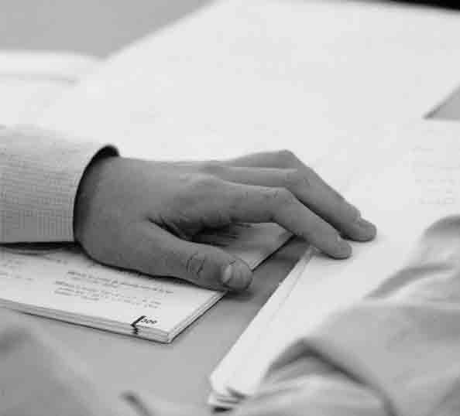

Technology-Assisted Lifelong Learning unit and Public Programmes Online Course Office
Department for Continuing Education
University of Oxford

Content and Copyright
In parallel to the writing process consideration needs to be given to the use of resources on the web or other digital media you would like to incorporate into your course. You may want to do this for several reasons:
- To provide an alterative perspective on a topic
- To support learning objectives and to illustrate a complex point
- To provide the basis for a learning activity and to stimulate discussion.
- To improve the user experience and avoid text fatigue.
- To offer students a different way of learning.

There is an ever growing body of excellent resources freely available online including:
- Images
- Audio and video material
- Maps
- Diagrams
- Scholarly articles
- Media articles (BBC, newspapers)
- Interactive simulations or games
- Fully online courses
- Online textbooks
- Databases (especially archaeological ones)
- Academic sites (project, departmental and individual)
- Museum, gallery and library sites
- Blogs

However depending on how you incorporate them into your course there can be copyright implications.

Linking or embedding
Digital resources can be presented to the student in two main ways: embedded or linked. The embedded resource requires copyright approval and appears within the course, whilst the linked resource appears in a new window, in its original location on the web after the student has clicked on the link to it.

 | Pros | Cons
Embedded resource | - Provides variety to courses.  - Allows student to compare two or more images.  - Can be manipulated to support a more complex learning objective.  - Allows student to easily move from text to resource. | - Copyright owner often makes a charge for use of the image.  - Tracing copyright owner can be time-consuming.  - Needs to be correctly located within the text to ensure student can cross refer.
Linked resource | - No need to get permission to use.  - Always free.  - Opens up in a separate window allowing student to see resource and course materials or forums simultaneously. | - Lack of visual stimulus in main course content.  - Need to check links before course release.  - Danger of broken links during course.  - Linked to page may contain other images and/or advertisements making it difficult to locate the desired content easily.  - With some sites that only provide links to a main page it may be necessary to give instructions on how to navigate their subsidiary pages to find the content.

If you choose to link to a resource then all you need to do is to provide the URL of that item in your course content, if you wish to embed an item you need to fill out our copyright request form.

The Copyright form
When you have decided to embed third party digital media in your course, you are now ready to initiate the copyright approval process. For this you need to understand what information is needed and why, how to get the information required and what to do if that doesn’t work out.

As an author you are the initiator of the copyright process and are required to fill in the Copyright Request Form. It takes anything from three weeks to three months to get copyright approval and in some cases it is never received.
Some of the delay is caused by insufficient information provided on the Copyright Request Form, especially in the section where a URL is required.

For further information.
To see what information is required for processing the copyright request, see the Copyright Request Form at the Authors’ moodle. http://training.conted.ox.ac.uk/course/view.php?id=12

Finding content
You may well know many excellent places to start looking for content on your subject area, but if you have not used the web much before you may find the following sites useful – please note that they will not necessarily provide links to free-to-use material:

- Intute - www.intute.ac.uk. A free online service providing access to the “very best” web resources for education and research. Note this also includes the Virtual Training suite to help you improve your web research skills and access resources tailored to the subject area that you selected for your tutorial
- Tasi - http://www.tasi.ac.uk/. Provides advice and training for project teams on the management of digital media, see especially Advice >Finding and Using Images> Finding Images Online section.
- Google Maps http://maps.google.co.uk/ and Google earth http://earth.google.com/
- ARTstor- http://www.artstor.org/index.shtml. ARTstor is a digital library of nearly one million images in the areas of art, architecture, the humanities, and social sciences. We have permission to use any images from ARTstor in our courses for free, and so it is an excellent source of images for embedding. You may not be able to access images in the ARTstor Digital Library if the computer you are using is not within the Oxford domain. If this is the case please speak to your project manger about ways to arrange access.
- Flickr - http://flickr.com/. Flickr is a photo-sharing site, but this does not mean you can freely use everything. However if you go the the Advanced Search option and choose "Only search within Creative Commons-licensed content" then we will easily be able to use these images.
- BUFVC - http://www.bufvc.ac.uk/. The British Universities Film and Video Council’s website is a comprehensive directory of the publicly accessible sources of material related to the history of moving images and sound in the United Kingdom.
- Google scholar http://scholar.google.co.uk/. Provides a search of scholarly literature across many disciplines and sources, including theses, books, abstracts and articles.
- Directory of Open Access Journals - www.doaj.org. This service covers free, full text, quality controlled scientific and scholarly journals
- ItunesU - http://www.apple.com/education/guidedtours/itunesu.html. Over 100,000 educational audio and video files from top universities, museums and public media organizations from around the world.
- OpenLearn - http://openlearn.open.ac.uk/ .Open educational resources from The Open University. Free online learning materials for all to use.
- YouTube.edu - http://www.youtube.com/edu. Youtube videos from universities and colleges. Note it is worth noting there are copyright issues with many youtube resources so always check with your project manager before making one a central part of an activity.
- Books- There are a growing number of schemes to make the full text of books available online. The following are some of the largest sources:
  - Project Gutenberg - http://www.gutenberg.org
  - Bibliomania - http://www.bibliomania.com
  - Google Book Search - http://books.google.com/

Alternatives to online content
While it often seems that the only place to look for resources is online there are alternatives
- Remember you can always direct students to the textbook – especially for images maps and diagrams.
- Photographs that you have taken, for example of buildings or public spaces may be used and in this case you own the copyright! The following information needs to be included on the copyright form: name of photographer, month and year, and title. A letter from the photographer granted approval to use the image is also required.
- It may be possible to scan illustrations or text from a book under the terms of the Copyright Licensing Agency higher education copyright and scanning licence. Speak to your project manager about this option if you are interested.

